官方文档：https://docs.bekencorp.com/arminodoc/bk_idk/bk7258/zh_CN/v2.0.1/get-started/index.html

一．Armino SDK代码下载

1.在主目录下创建一个armino文件夹，然后进入此文件夹

mkdir -p ~/armino

cd ~/armino

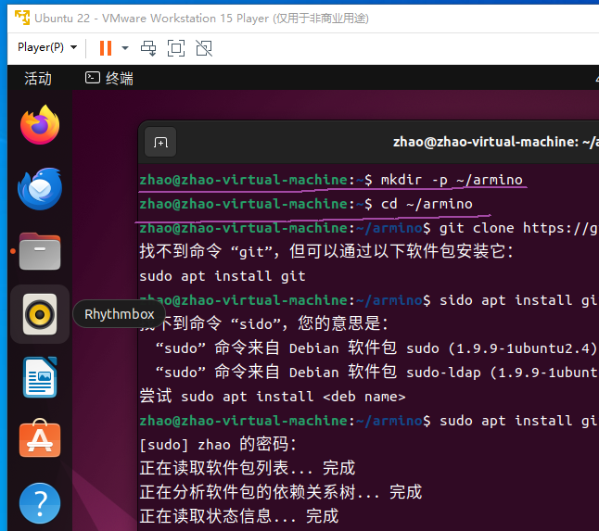

2.安装git，输入密码后进行下载

Sudo apt install git

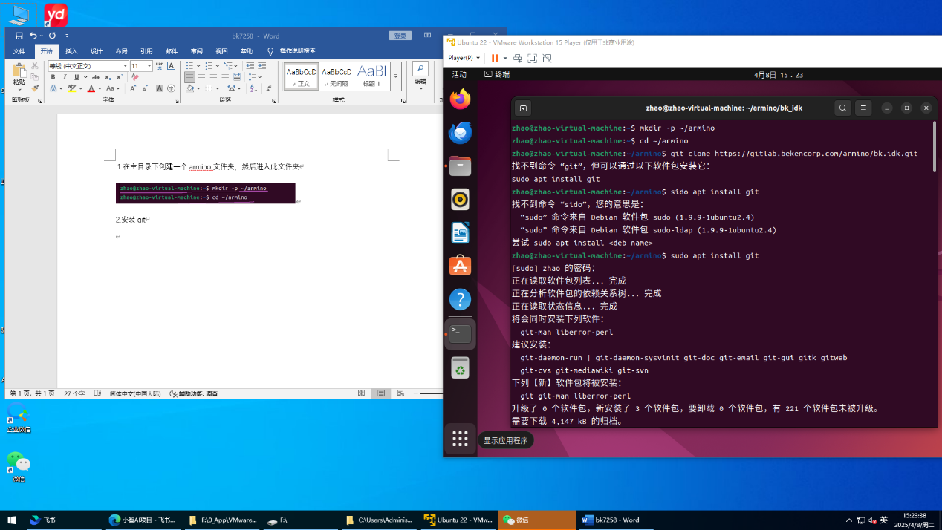

3.配置环境变量

出现软连接问题git config --**global** core.symlinks true

出现换行符问题git config --**global** core.autocrlf false

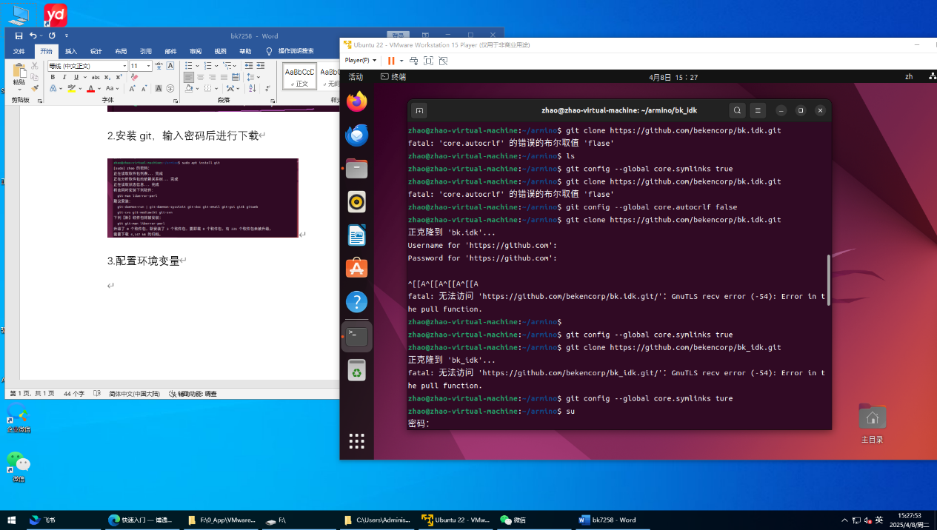

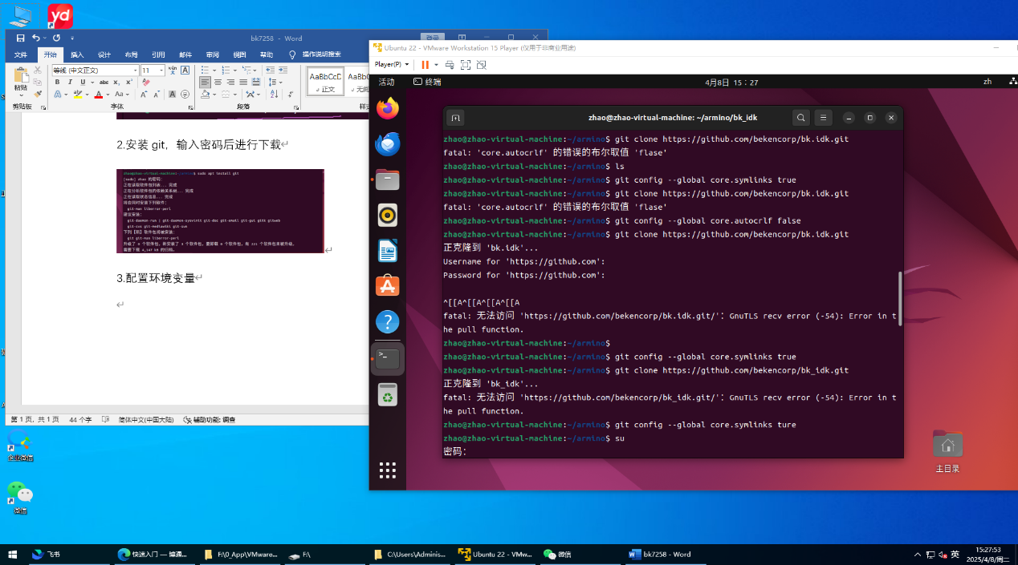

4.从github上下载armino

git clone https://github.com/bekencorp/bk_idk.git

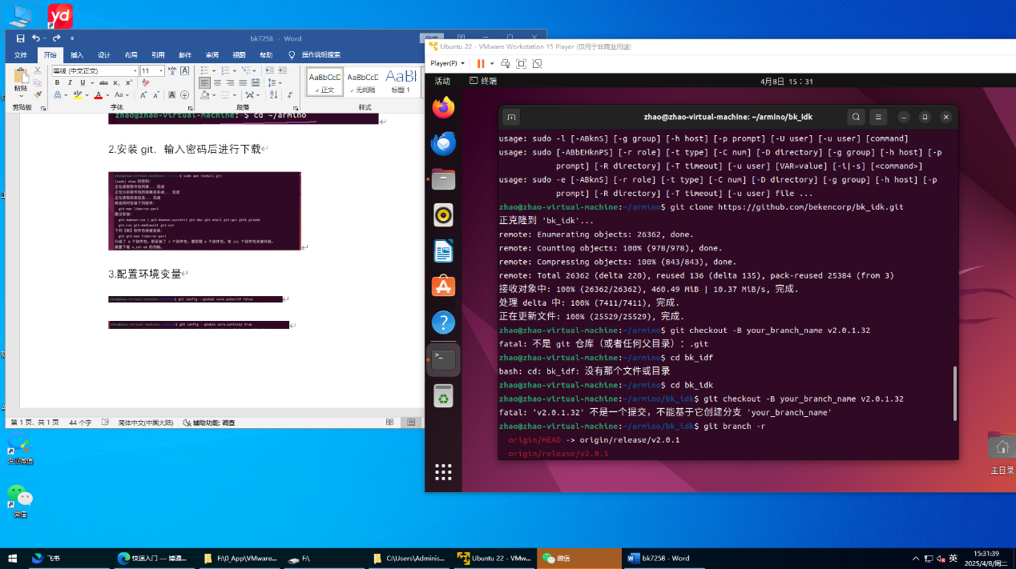

5.切换Tag节点：v2.0.1

查看brancg节点git branch -r

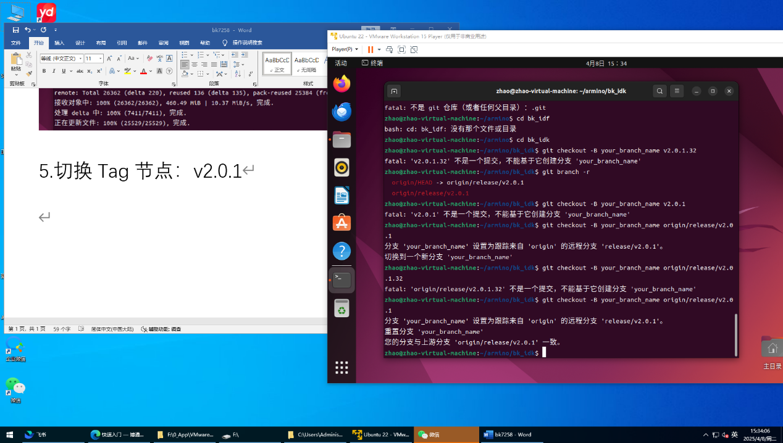

切换节点git checkout -B your_branch_name v2.0.1

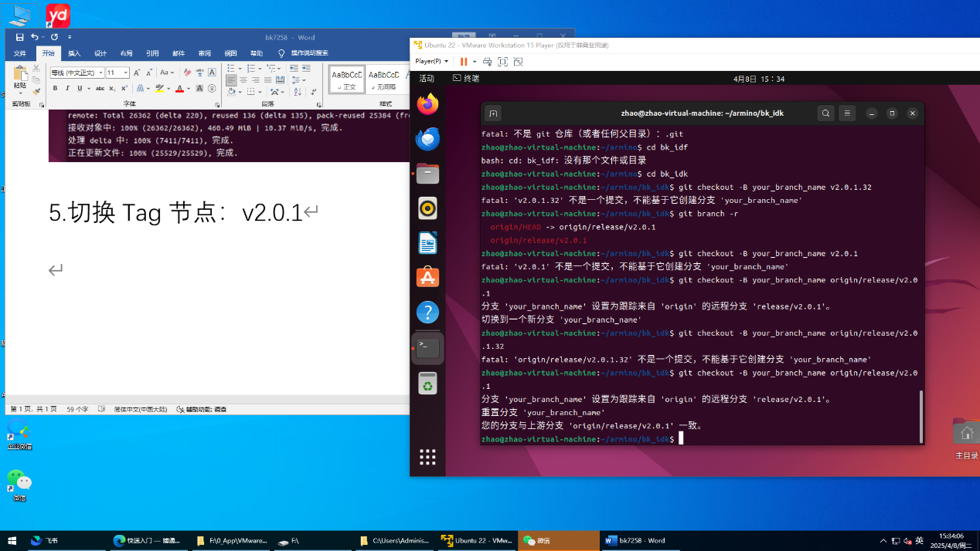

二．环境部署及编译

1.选择本地部署-手动安装-下载工具链

使用火狐浏览器打开以下链接下载

<https://dl.bekencorp.com/d/tools/toolchain/arm/gcc-arm-none-eabi-10.3-2021.10-x86_64-linux.tar.bz2?sign=RXdqFf5PRB5upxFDS7UXTUtTsStCbrQgoAfcUDJe9M8=:0>

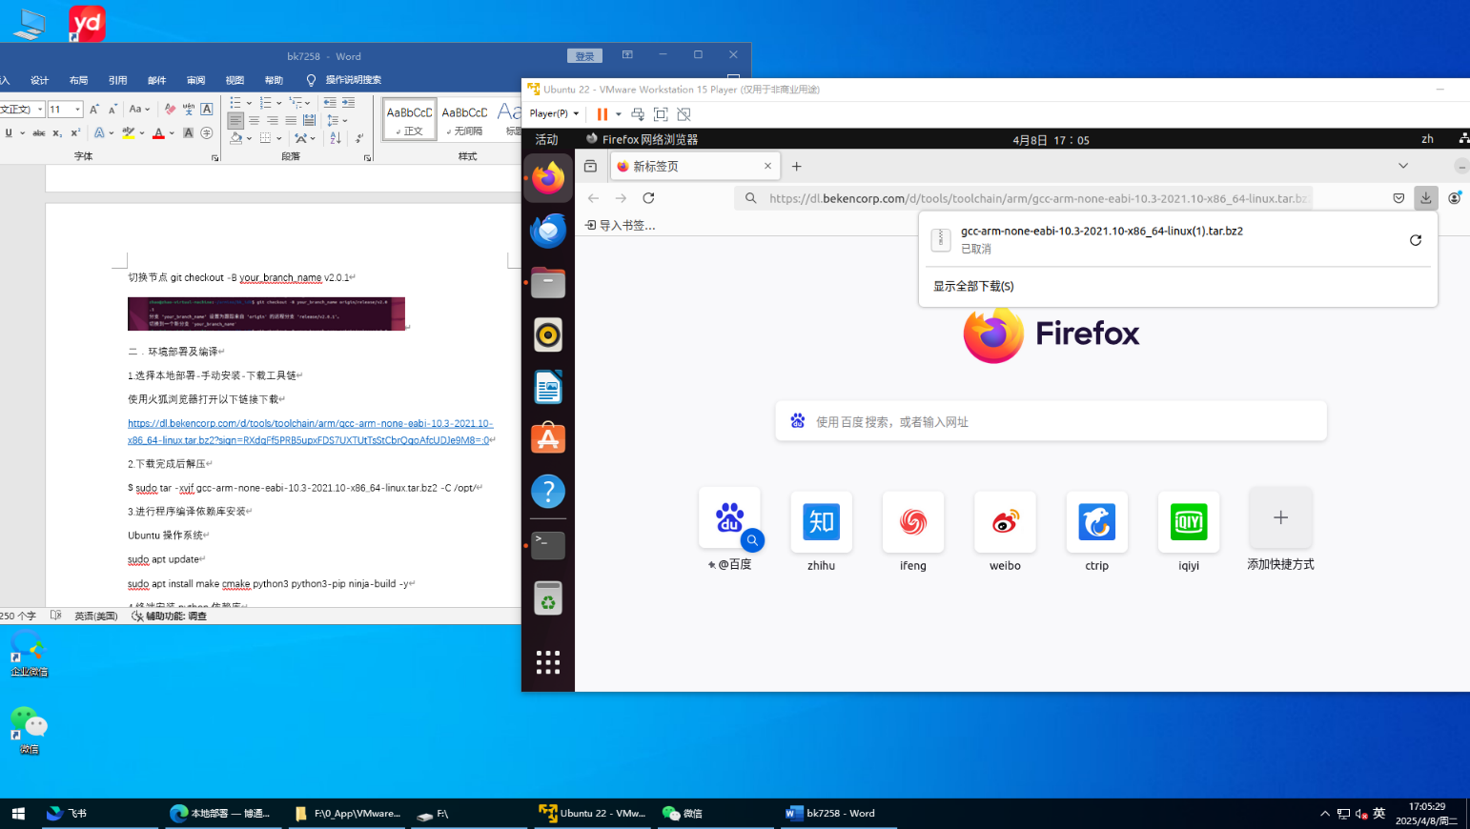

2.下载完成后解压

$ sudo tar -xvjf gcc-arm-none-eabi-10.3-2021.10-x86_64-linux.tar.bz2 -C /opt/

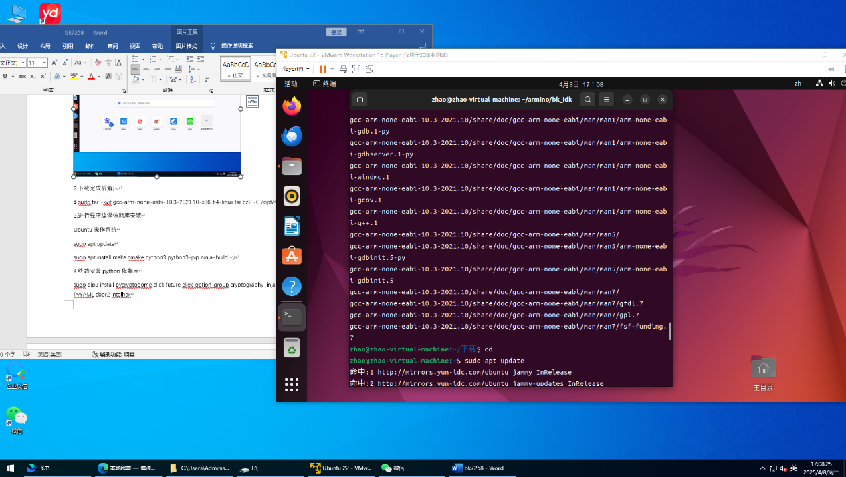

3.进行程序编译依赖库安装

Ubuntu操作系统

sudo apt update

sudo apt install make cmake python3 python3-pip ninja-build -y

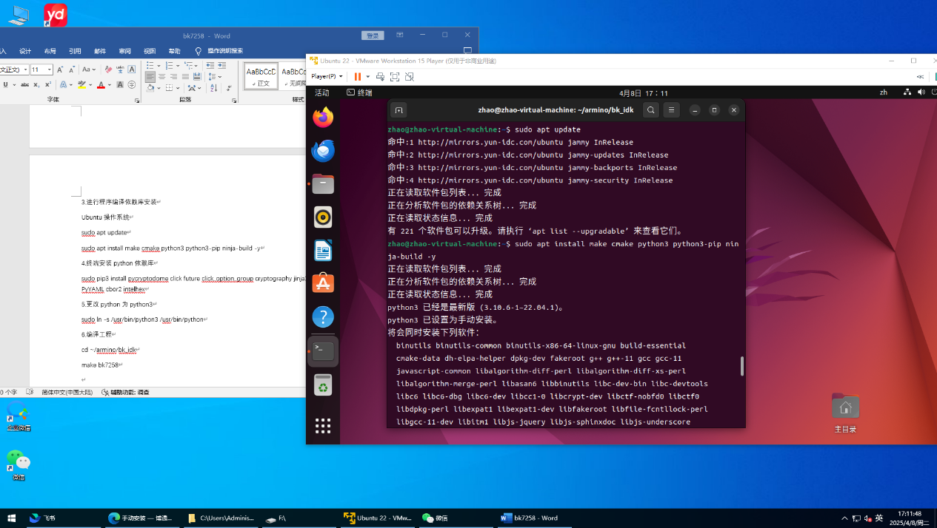

4.终端安装python依赖库

sudo pip3 install pycryptodome click future click_option_group cryptography jinja2 PyYAML cbor2 intelhex

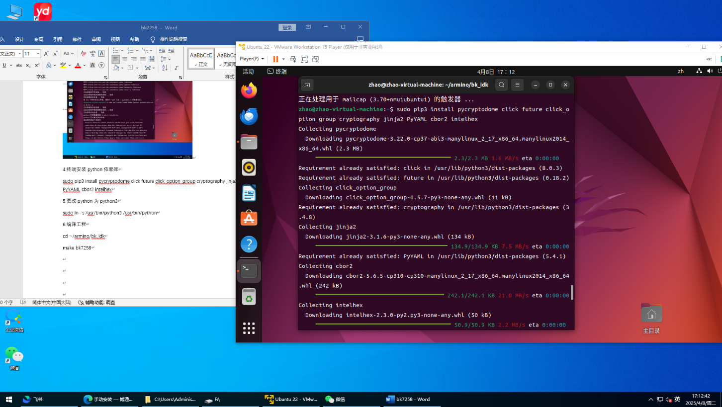

5.更改python为python3

sudo ln -s /usr/bin/python3 /usr/bin/python

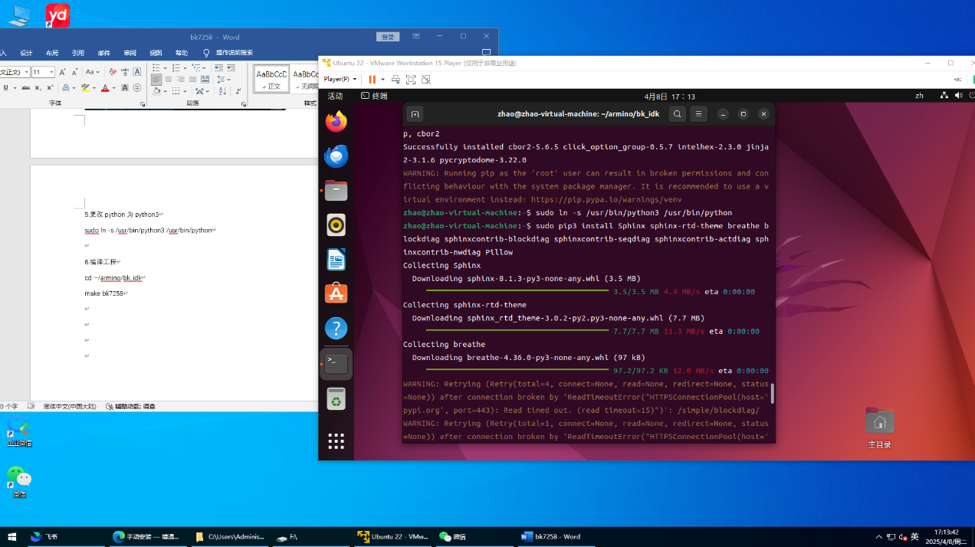

6.编译工程

cd ~/armino/bk_idk

make bk7258

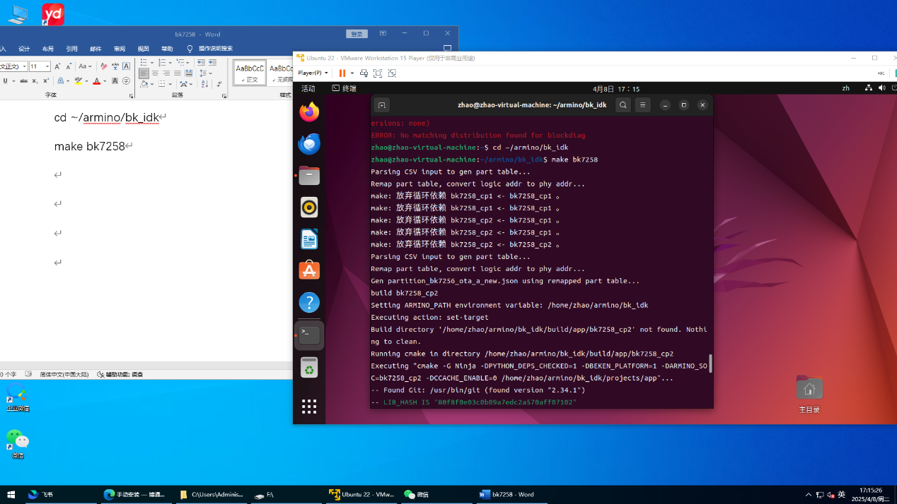

7.编译成功

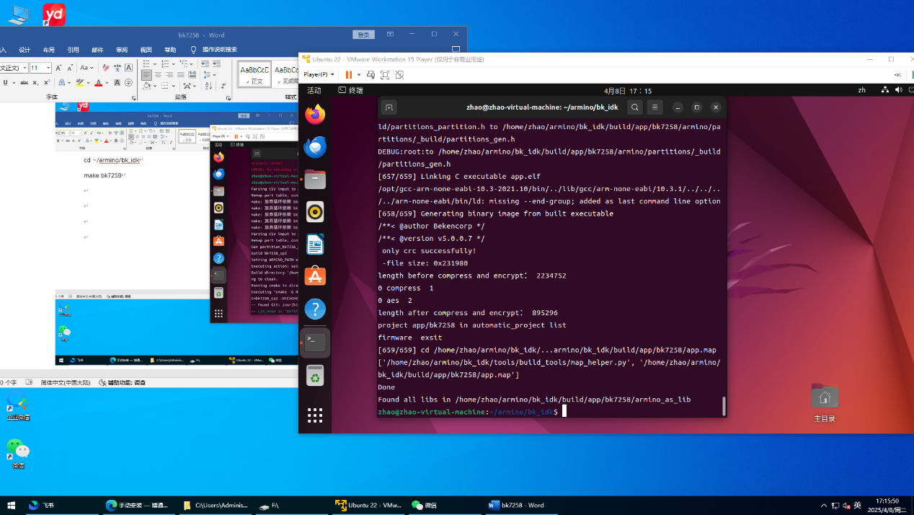

三．本地SDK下载配置

1.通过windows与ubuntu互传，将 FCM665DAAR01A01M08_V01_doubao_CSDK在ubuntu上进行压缩

2.安装python3依赖库

sudo dpkg --add-architecture i386

sudo apt-get update

sudo apt-get install build-essential cmake python3 python3-pip doxygen ninja-build libc6:i386 libstdc++6:i386 libncurses5-dev lib32z1 -y

3.进行编译

make bk7258 PROJECT=quectel

